**SHIMONI DEMONSTRATION SCHOOL- KIRA**

**MID TERM TWO EXAMINATIONS, 2023**

**MIDDLE CLASS, READING**

**Name ____________________________________________________**

1. Match the words and draw.

bag pot ______________

Chair box_____________

box table____________

table bag_______________

pot Chair _______________

1. Fill in the missing sounds.

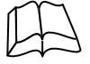b___ ___k h___ ___se

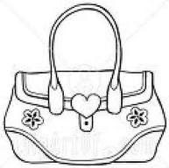

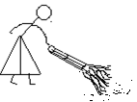 b___g 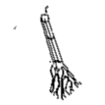br____ ___m

1. Join sounds and form words.

ox___________

b ag ________________

ook ________________

at ____________

M an__________

oon ___________

1. Read and draw.

|  |  |  |  |
| --- | --- | --- | --- |
| It is a mat | It is a basket | This is a tin | It is a man |
|  |  |  |  |

Sound this

oo ee ou ck br